Access Tutorial
  - How to access Access

What is Microsoft Access
- Database manager
- Made up of tables that are interconnected to allow for data analysis
- Queries can be performed to manipulate your data, such as join tables, filter tables, update data, make new tables
- Queries can be automated through building Macros

How are the tables connected?
- Go to Database Tools/ Relationships
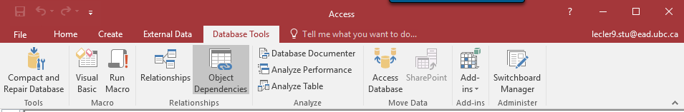
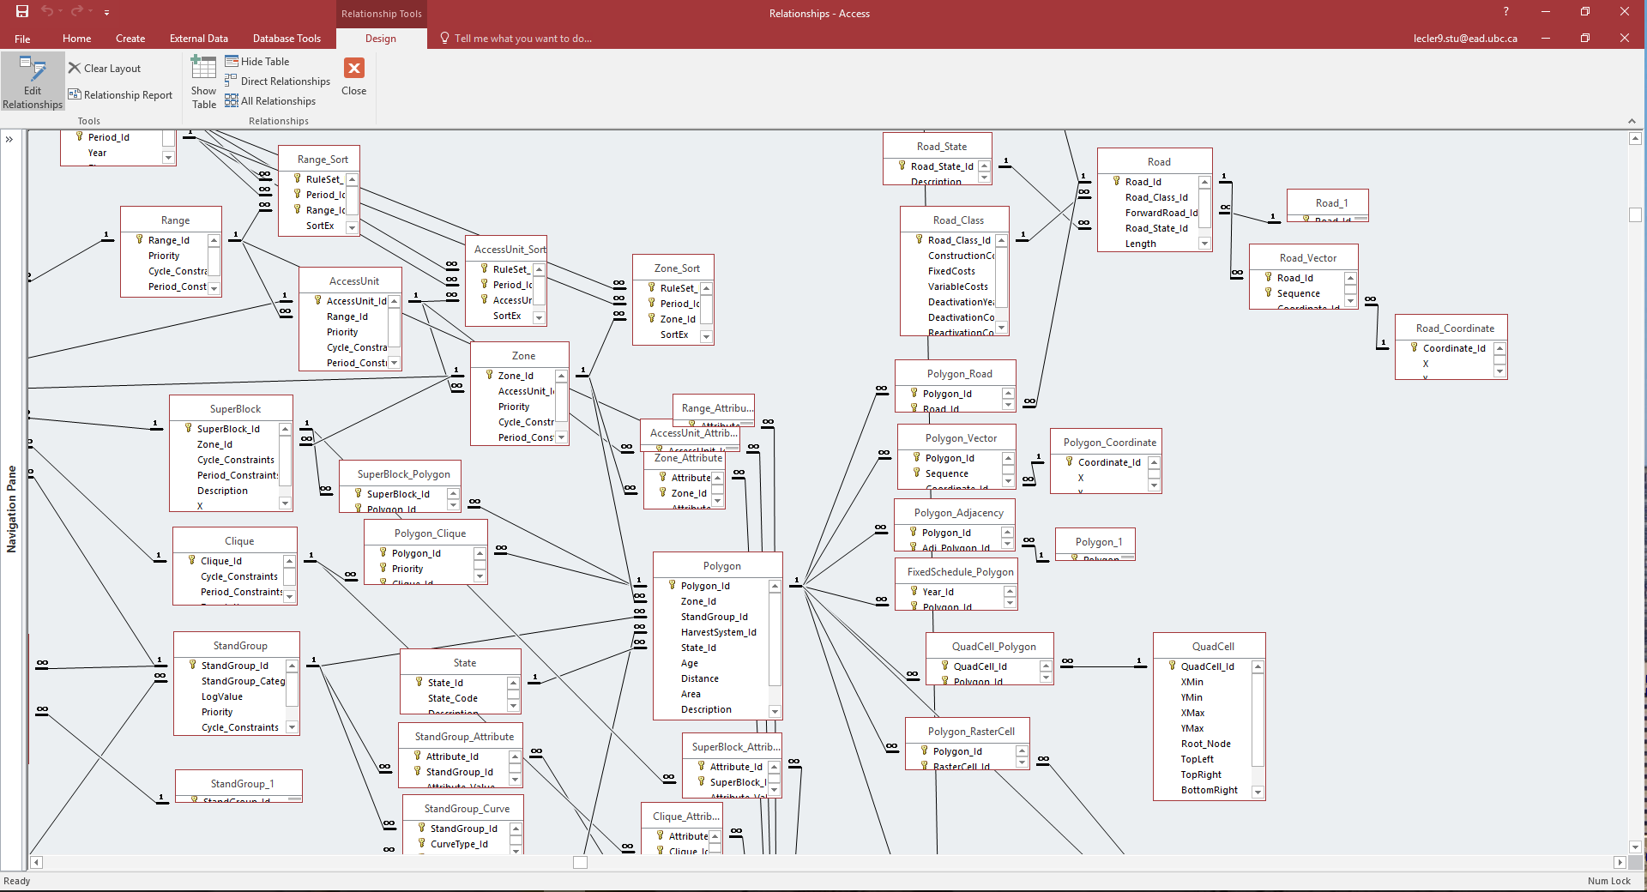
- Every table is connected via a “Primary key”
- Primary key is one or more fields (column) that exists in every table and “links” tables together
  - No duplicates
  - Not to be changed
  - Unique identifier
- “Foreign key” is one or more fields in a table that refers to a primary key
  - Can have duplicates
- E.g. State_ID.State is a primary key for the State table, but is a foreign key in the Polygon table
- You can tell which is which by the symbol in the map, the 1 signifies primary key and the infinity symbol signifies foreign key
- If you delete a primary key, make sure you understand what tables it was connected to and how they are all interlinked!

Access and FPS Atlas
- FPS Atlas is a visual and spatial representation of all of your Access tables
- Changes in these tables will be translated in FPS

Descriptive Statistics
- Quickly summarize data in Access
- Open a table
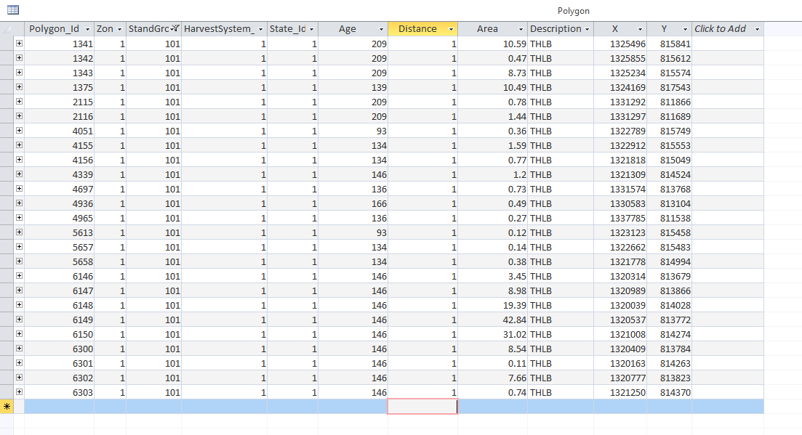
- Select “Total” under the home tab
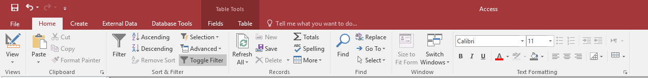
- An extra row will appear at the bottom of your table. These will have a drop down arrow with different descriptive statistics you would like to select
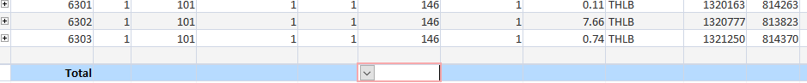

Queries
- Answer specific questions about your data that would be difficult to answer by looking at the data directly, good for descriptive statistics
- 3 main actions: Append a table, update a table or create a table

Queries – Update a table – Defining a Zone
- First, we need to define our zones. For this example we will be assigning 2 zones: Timber harvest landbase (THLB) and a non-timber harvest landbase (NTHLB)
- Open the Zone Table and define each zone
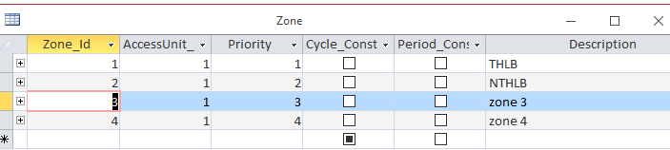

- Then we will create a query to do this update.
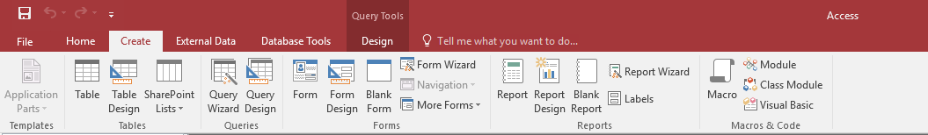
- Under “Create” tab, select “Query Design”

- Select the table that holds the data you would like to look at or change
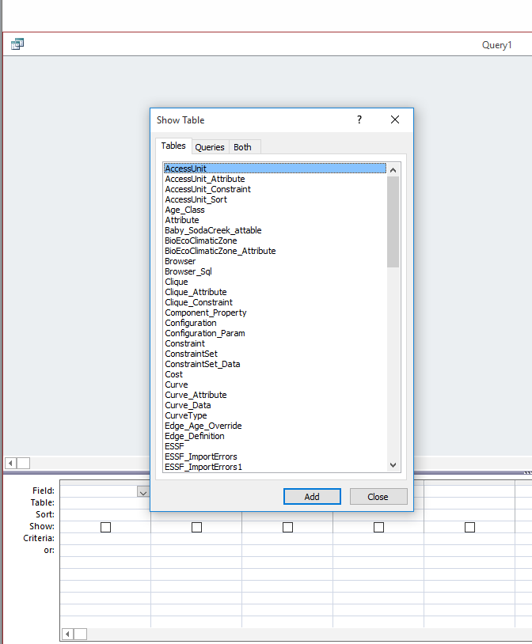
- Click on “Update”
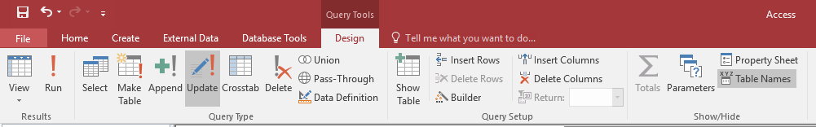

- There are 4 main rows to build a query:
  - Field: Column of data you want to look up
  - Table: From within which table you want to look up
  - Update to: If you wish to make changes to a specific field, in this row you specify to what you want it to change to
  - Criteria: Specific criteria that the data will only be processed for those particular cases
Example:
Update stand group 4 from THLB to NTHLB
- Field: Zone_ID
- Table: Polygon
- Update To: “2”

- Field: StandGroup_Id
- Table: Polygon
- Update To:
- Criteria: =4

- Field: StandGroup_Id
- Table: Polygon
- Update To:
- Criteria: =5

- Field: StandGroup_Id
- Table: Polygon
- Update To:
- Criteria: =3

- Field: Description
- Table: Polygon
- Update To: “NTHLB”.
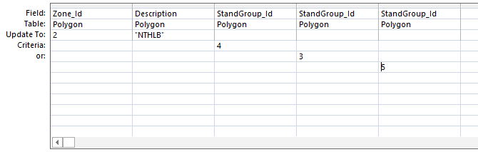

So, stand group “4” will be updated to zone 2 and the description updated as NTHLB within the Polygon table.
****THINGS TO REMEMBER****
- ”Criteria” row needs to be written using =, >, < symbols. The “Update To” row can use either “ “ or =

Queries – Append a table - Making a Clique
- First, Cliques need to be defined in the Clique Table. We will keep it simple by only creating 3 cliques: Moose Habitat, Dead pine, Regen.
- Open the Clique Table.
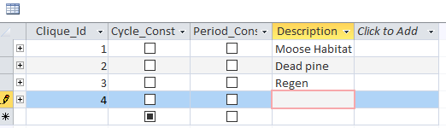
- Then we will create a query to do this.
- Open the Polygon table in the query.
- Select Append under “Design”
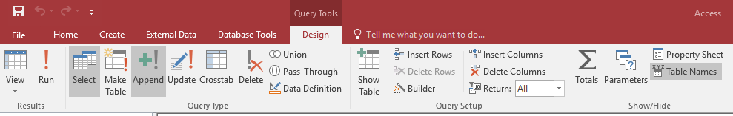
- Then select “Polygon_Clique for the table to append.
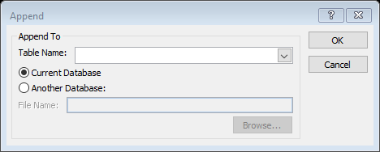
- Fill out the query as follows:
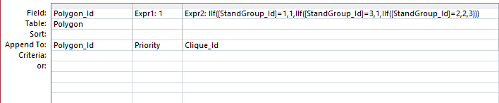

- Field: Polygon_ID
- Table:Polygon
- Append To: Polygon_Id
What this is telling Access is to take the Polygon_Id values from the Polygon table and append them to the Polygon_Id field in the Polygon_Clique table
- Expr1:1
- Append To: Priority
What this does is assigns a value of 1 to the Priority field in the Polygon_Clique table.
- Expr2: IIf([StandGroup_Id]=1,1,IIf([StandGroup_Id]=3,1,IIf([StandGroup_Id]=2,2,3)))
- Append To: Clique_Id
This nested IF function is assigning the designated stand groups to 3 different cliques: If StandGroup_Id is equal to 1, then assign it a value of 1, If StandGroup_Id is equal to 3, then assign it a value of 1, if StandGroup_Id is equal to 2, then assign it a value of 2, if not, assign it a value of 3
So StandGroup “1” and “3”, will be assigned to Clique 1 (Moose Habitat), “2” to Clique 2 (Dead pine) and all remaining stand groups to Clique 3 (Regen).

