TREATMENTS IN FPS
Treatment | GoTo (Curve=StandGroup) | Treatment Values - residual Forest | Apply Age | Post Entry Age | Generate harvest volumes?
Clearcut | Typically a new curve or standGroup (ie. TIPSY) | None | Usually culmination – some large number | FPS sets age to 0 | 
Partial cut | Typically “myself” but can go to a new curve or standGroup * | User defined in m3/ha | Will determine the minimum amount to harvest. Take the difference between the age @ the residual growing stock and apply age to find the min amount to harvest. | FPS set to age @ user defined residual forest | 
Thinning | New curve that reflects the residual volume after thinning and reflects the growth response after the thinning** | % volume removal | Age at which thinning will occur*** | Age remains unchanged | 
Succession | typically “myself” but can go to a new curve | Age of new stand | Age of when to transition | FPS assigns the age you set in the treatment value | No
Rehabilitation | The rehabilitation curve | None | Age of rehabilitation treatment | Unchanged | No
*if a new curve is set in the Goto tab, the first entry on the yield curve will have the residual volume set by the user. This can be done by creating a new curve (File –New- Curve) with X-Initial set to the year of the residual growing stock needed.
**At thinning, FPS transitions to a new curve with the age set as “Apply Age”. This new curve needs to reflect the residual volume after thinning and include the volume growth response
***To ensure the thinning happens in this window you may need to set the default extra sort to “1-by SGroups” this is in the Param tab
Multiple volume removing treatments are not allowed within a stand group -> instead use multiple stand groups
Steps for thinning – Needs a few new yield curves or stand groups
Thinning Prescription: Thin at year 70 to 51% of the volume.
Step 1: Examine the Existing Curve:
At 70 years the volume is 195 m3/ha and 51% of 195 m3/ha is ~ 100 m3/ha
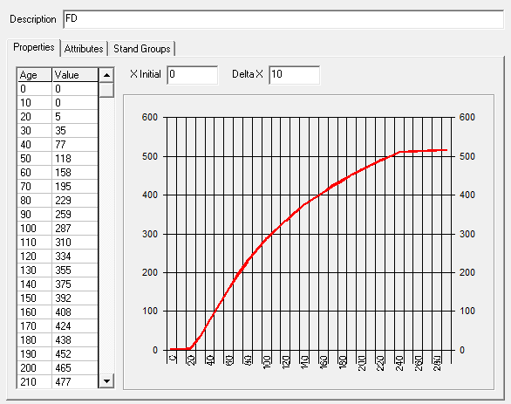
Step 2: Create a Curve for THINNED Stands (can be done in PROGNOSIS).
Notice the Volume per ha after 70 years is reduced by 100 m3/ha
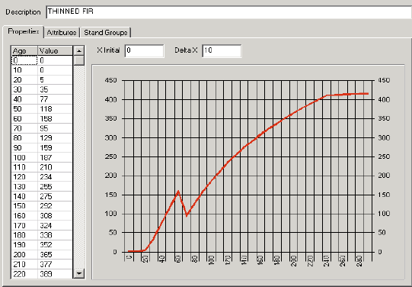
Step 3: Create 2 new stand groups – Thinned and Young
YOUNG -> actually your existing curve for stands that will be thinned. Its GoTo is THINNED and its treatment type is Thinned and you enter 51% for the removal (in this example).
THINNED-> This curve is either the prognosis curve or the curve that reduced volumes after 70 years by 100 m3/ha. Its goto is YOUNG and is harvested with a Clearcut treatment to reset the age.
Step 4: Assign the existing stand groups to the new Stand Group YOUNG
Eligible stands Query ->
Map Viewer – Right Click –Execute SQL – Modify the SQL Syntax

Ex. “SELECT Polygon_Id FROM Polygon WHERE StandGroup_id=1 and age > 69 and age < 101”

Assign existing stand groups to the StandGroup -> YOUNG
Map Viewer – Right Click –Fenced Operation -> choose “YOUNG”
Step 5: Set the priority and extra default sort. Tools-User Customization – SGrp and move Young to the top of the list

