PROCEDURES TO IMPORT AN FPS/ATLAS DATABASE FROM A GIS RESULTANT FILE
January 10, 2014

Start with the blank database. Blank_Database.mdb

Rename it Keyoh5_Data_Demo.mdb (here after called the database).

Open the database with MS Access

Import the resultant dbase file from the GIS resultant shape file
External Data/More/Dbase file….Resultk5.mdb

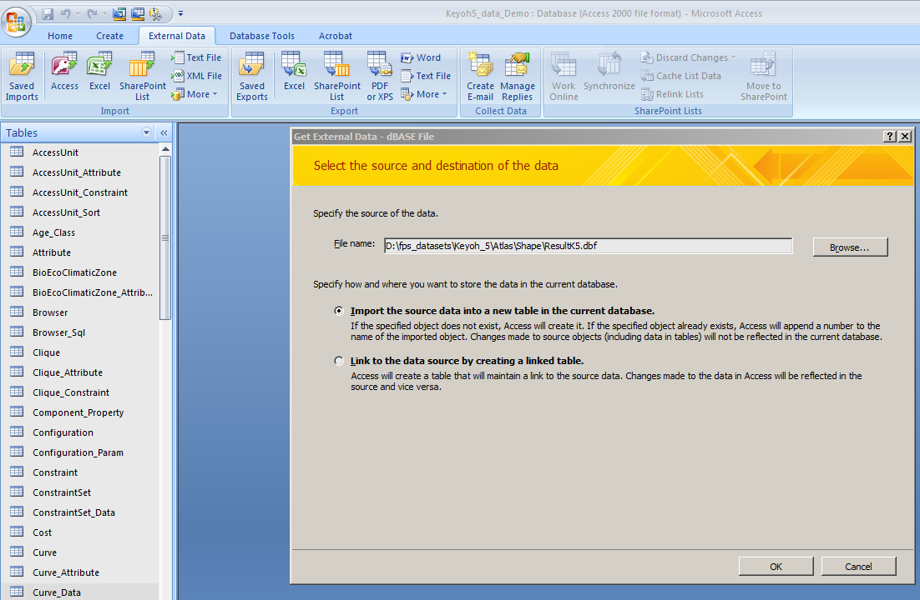

Resultk5 is now a table in the database and we can use it for queries to fill in the rest of the tables.
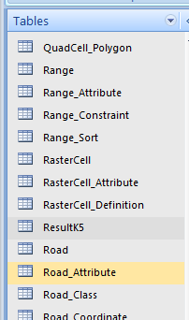

Now populate the polygon table using Resultk5 data in an append query:

Here is the empty polygon table
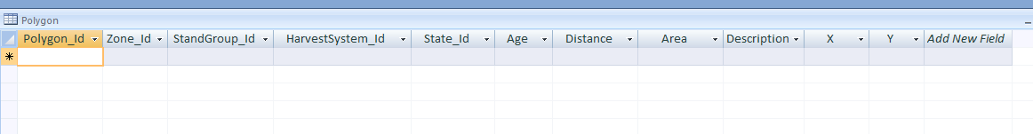

We import as many fields as we can from the Resultk5 table. A lot of fields are given default/dummy values (e.g. Zone_ID=1, Stand group_ID=888, X and Y coordinates= 1) and these will be updated later with update queries. In many cases additional records need to be added (Stand Group tables) before the polygon table can be updated. This is controlled by referential integrity.

This is the append query
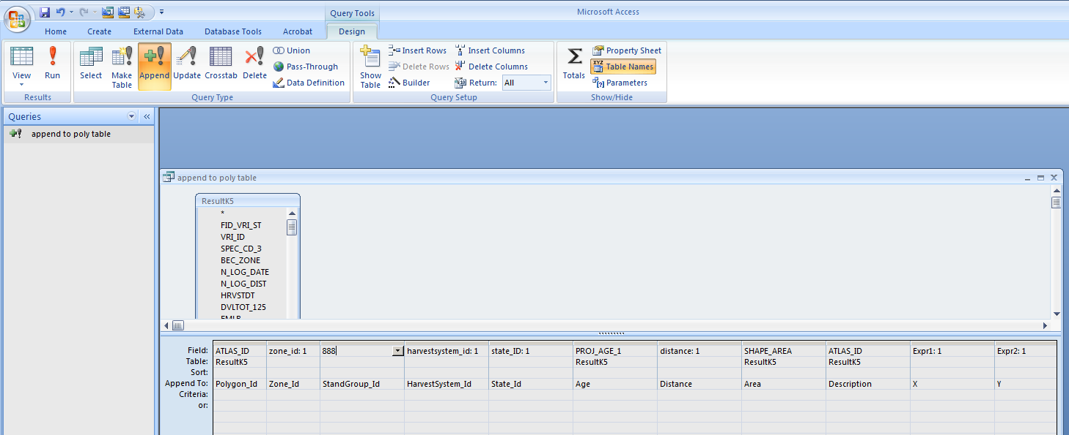
This is the populated polygon table.

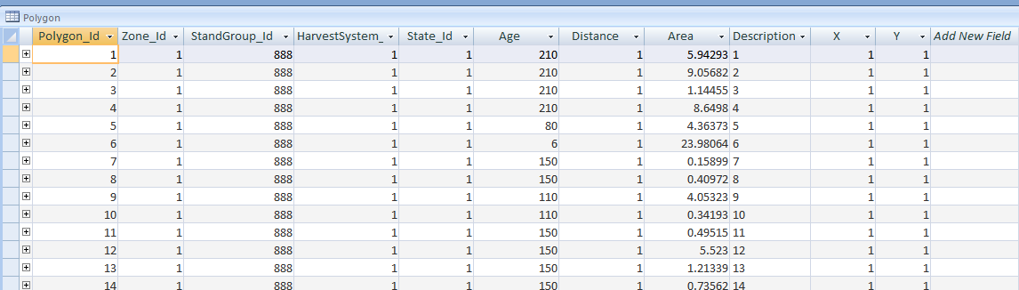

Next we need to import/link the spatial data in the Resultk5 shape file to the database. This is done by the Data Wizard in FPS

Start FPS and open the database Keyoh5_Data_Demo.mdb with FPS. Under Tools/Data Wizard/ select Shape file import

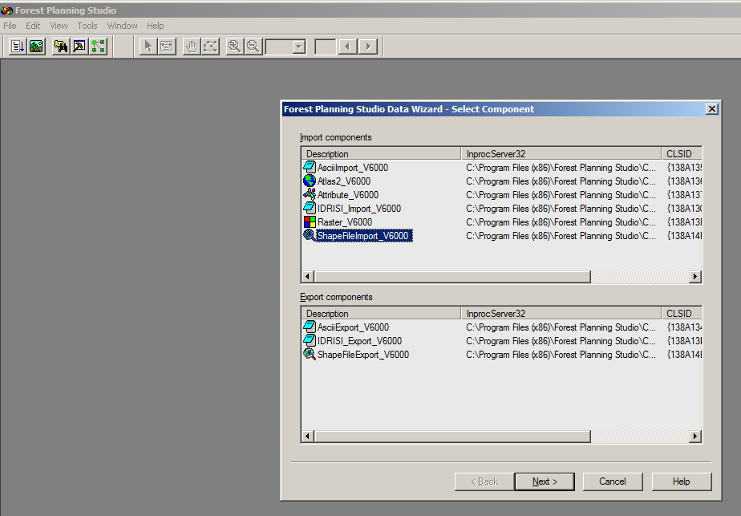

First, change the Default Path to the path to the shape file you want to import//link

Next, change the shape file name and the field in the shape file that is the link to the polygon_ID – in the case = ATLAS_ID

We are not importing/linking roads or streams, so those boxes are unchecked.

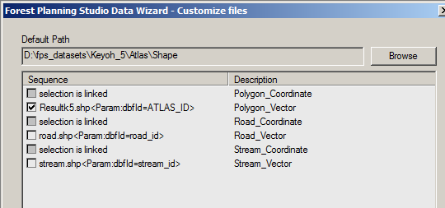

Uncheck the “Save within database, else link to original files” (Links to shape file rather than importing data into the database (see table External_Import once the import is complete)

Check Compress Spatial Network (this creates parameters for the FPS viewer, including quad cells)

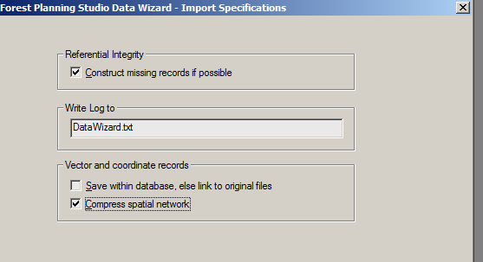

Click finish

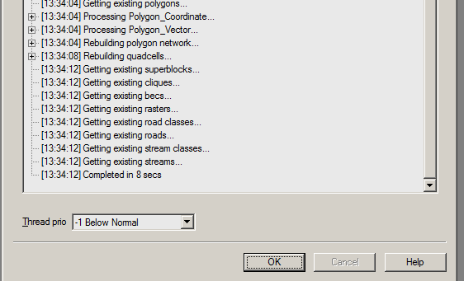

OK… Open the FPS viewer and you should see the map displayed (Resultk5.shp)

Here is the link to the shape file in the table External_Input. If you move the shape file, move to another computer with different paths to the shape file, just change the Value1 field which is the path to the shape file
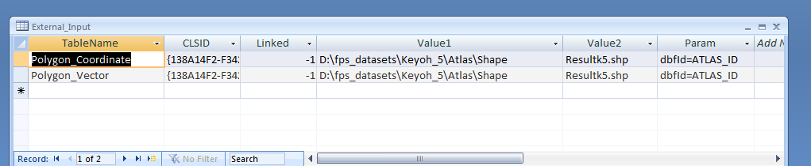

_______________________________________________________________________

Compact & repair the database.

IMPORTING STAND GROUP TABLES

The Stand Group Tables and Relationships

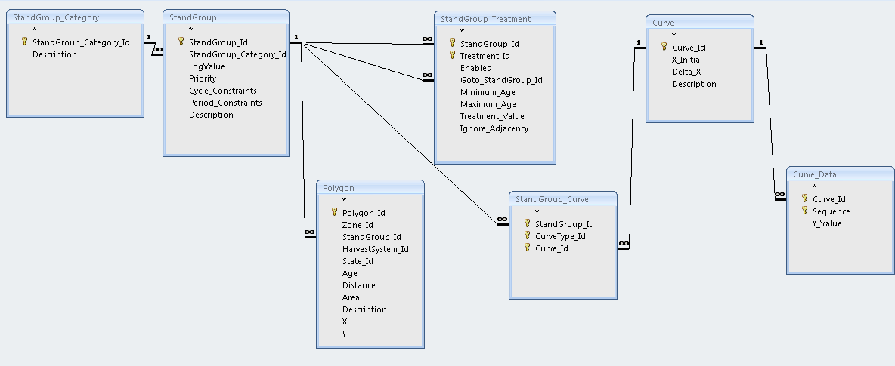

Order of Import (records must exist in higher level tables or imports fail)

- Stand Group Category
- Stand Group
- Stand Group Treatment
- Curve
- Stand Group Curve
- Curve Data

When all the Stand Group Tables have been imported, then we can use update queries to update the StandGroup_ID field in the polygon table.

The stand group data will be imported from the Excel file GY_Keyoh5.xlsx

Open the spreadsheet to the FPS_Tables worksheet. Copy and paste the table information in excel into MS Access. Don’t copy the headings, just the data.
In MS Access, right clicik on the * and paste. You will get warnings about duplicates – it’s OK they are the default values. Just make some minor edits to match the spreadsheet.

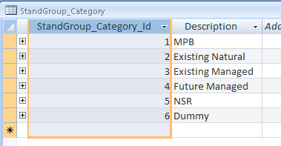

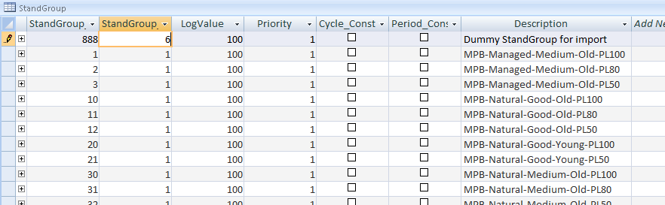

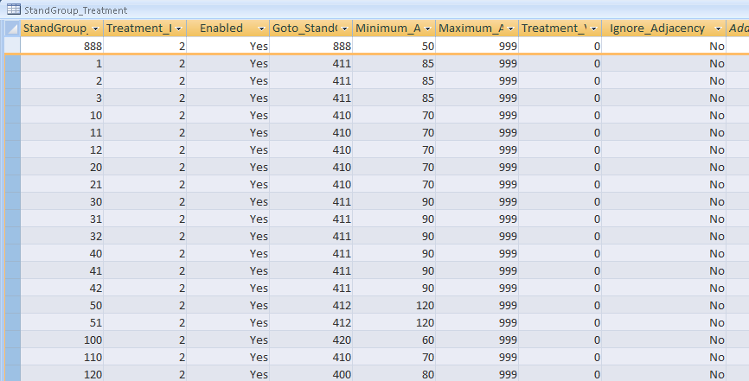

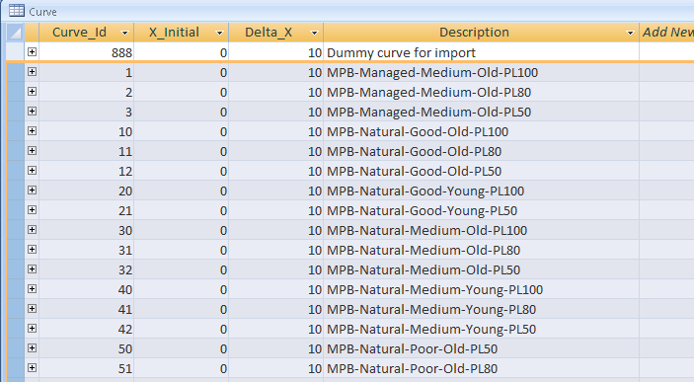

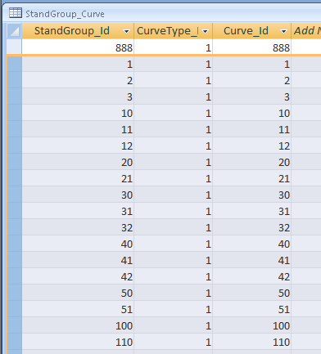

Look in the worksheet GY to find the curve data formatted for import
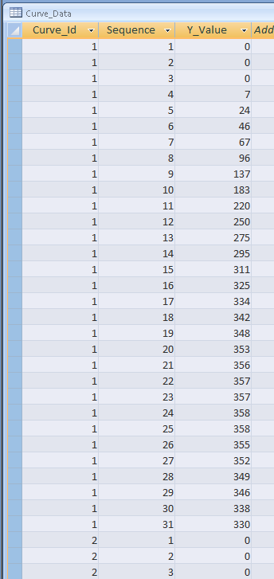

UPDATE DATA FOR NON-FOREST POLYGONS

Non-Forest Polygons – use an append query to add non-forest polygons to the table Polygon_Attribute

Attribute 5 means it is a surface type attribute, value >0 means it is non forest and will be ignored by FPS – i.e. it doesn’t age these polygons. (I think 1 is water and 2 is bare ground?)

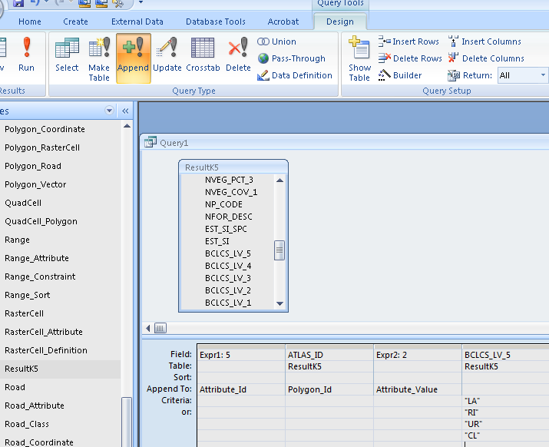

This query appends all polygons that have BCLCS_LV_5 = LA or RI or UR or CL. Other values might be for rock, swamp,,,etc. You can separate dirt from water, depending on the Attributer value. You don’t have do it all in one query – multiple queries if you like.

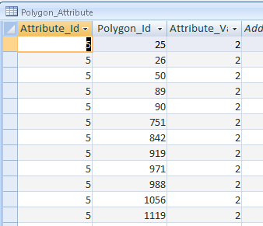

UPDATING THE POLYGON TABLE

Use Update queries to change STAND GROUPs, ZONES, ages, etc. in the Polygon table

This query updates standgroup_id to 30 for all polygons that have species code 1 = PL, site index between 12 and 20 and age>50 years. Note the relationship made between ATLAS_ID and Polygon_id. This is the link between the two tables.

Repeat for all stand groups. Any polygons not updated will have the default import value of 888 and you can then investigate these further.

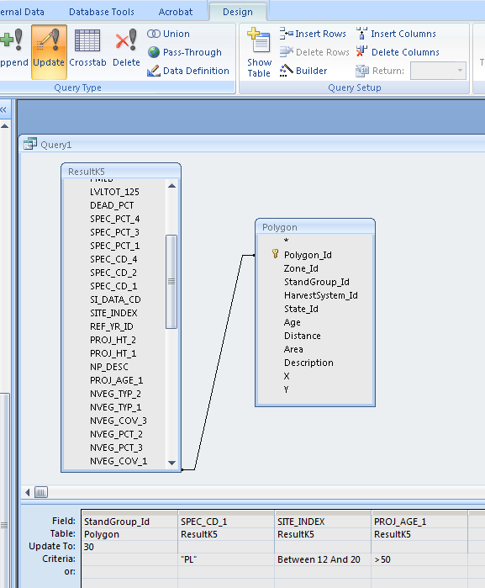

ADDING CLIQUES

Use append queries to add polygons to the table POLYGON_CLIQUE

First, the Clique must exist in the Clique table

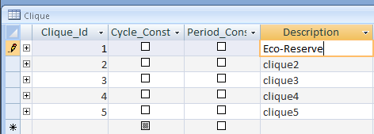

This query appends polygons to clique 1 in the table Polygon_Clique for all polygons where the ECO_RESERV field is >0. Priority is typically 1 and it is only used in the FPS viewer for which clique is displayed over top of others. I leave them all at 1.

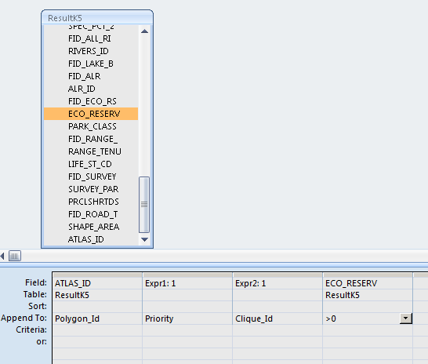

Repeat for all Cliques.

Check for duplicates in the Polygon_Clique table. First, update all priorities to 1. If there are duplicates, the priority will be >1 These can then be deleted from Polygon_Clique.

COMPACT THE DATABASE

